**Lab 6:** JMP instructions

**Goals:**

1. How to compute means for groups of data
2. Reminder: log transformations

**Computing means for groups of observations:** uses patty.txt.

The patty data set has 3 plate counts for each hamburger patty. The bacterial concentration was measured three times for each patty. In the language to be used shortly, the experimental unit is the patty; the observational unit (in the original data) is plate count. This is a violation of independence. A more appropriate analysis is based on the average count per patty. After averaging, the observational unit is the patty (because one row of data per patty), which is the same as the experimental unit (good).

The strategy is to calculate the averages for each patty and save them in a new data set. Then, we will analyze that new data set.

Read the patty.txt file. This has spaces between each field, so you will need to tell JMP that (Data import Best Guess or Preview). The result should be a data table with three columns: trt, rep and cfu. There are three cfu values for each rep. We want to average each set of three to get a single mean for each combination of trt and rep.

Select Tables / Summary from the main menu. Define what you want JMP to do in two steps:

1. Put trt and rep into the Group box. This specifies what combination of values identifies each unique group. It doesn’t matter whether a variable is continuous (blue ramp) or nominal (red bars).
2. Select cfu (the variable that will be averaged), left click the black arrow by Statistics to open the Statistics menu, choose mean. At this point, the Summary dialog box should look like:

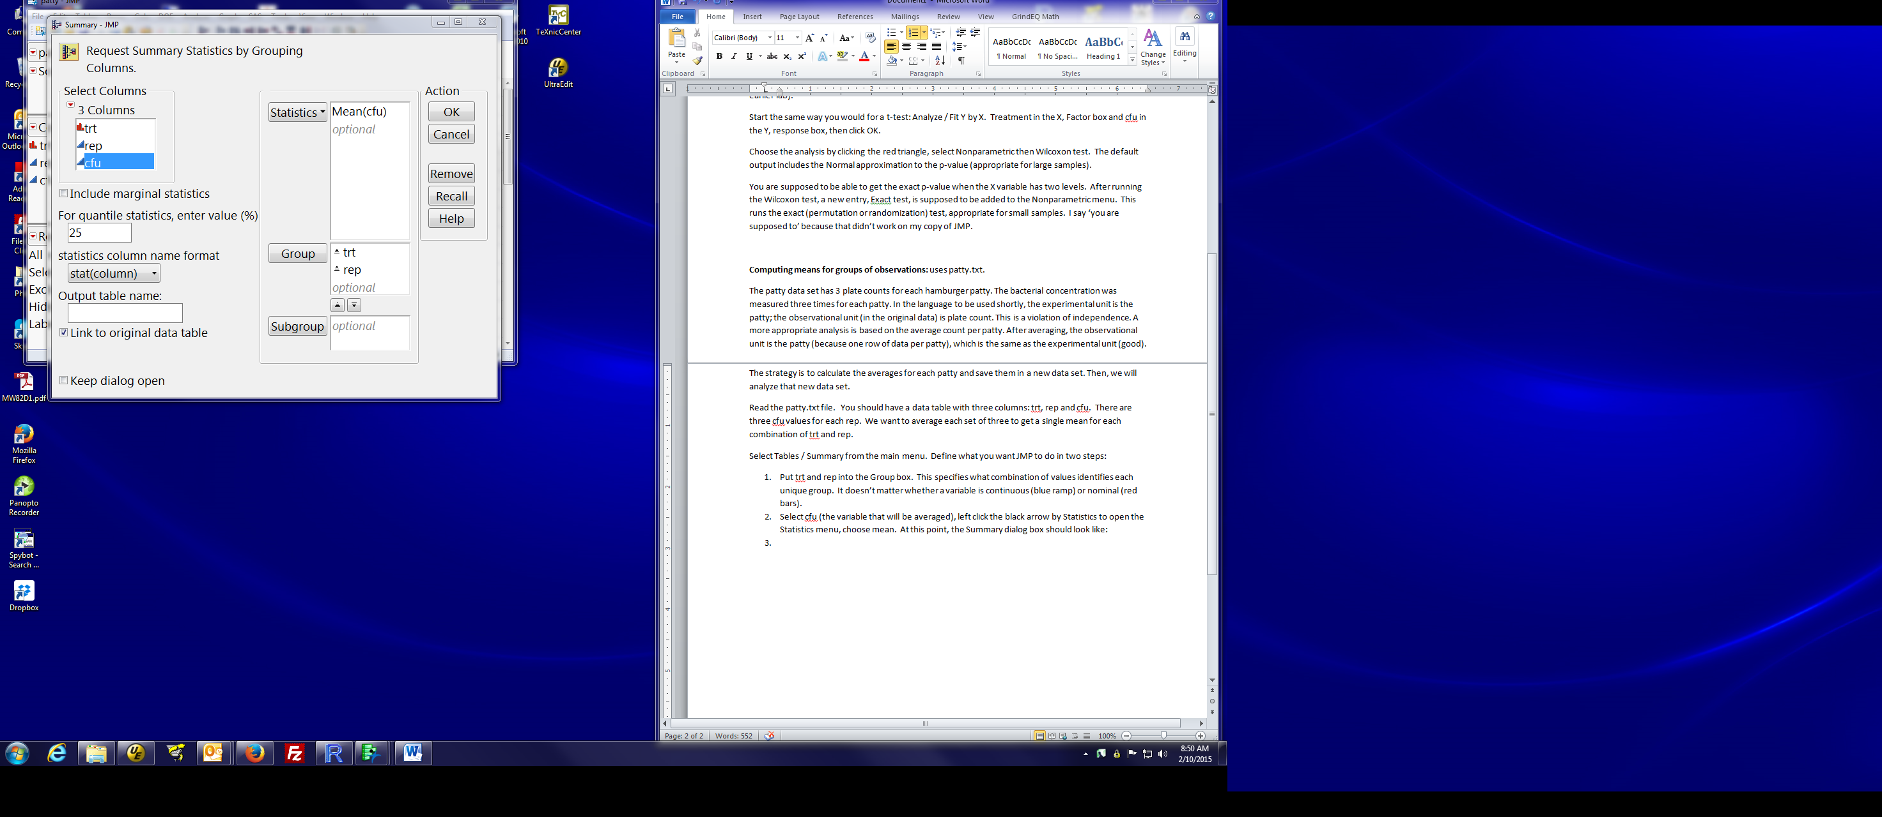

Click OK. You get a new data table with 12 observations, one for each hamburger patty (i.e. combination of treatment and rep). You then use data set for subsequent plots or analyses.

Options:

in the dialog, you give a specific name (Output table name) for the data table in case you don’t like the name JMP generates for you.

After you get the new data table, you can change variable names.

Note: Be careful which window is active when you request an analysis.

When you request an analysis from the menu in the patty By (trt, rep) window, the analysis uses the 12 observation data set.

When you request an analysis from the patty window, the analysis uses the original 36 observation data set.

My practice is to minimize or close a data window I no longer need to use.

**Log transformations:** (Reminder, details in lab 4 documentation)

Transformations are done by creating a new column and defining its contents using a formula. We did this in lab 4 to calculate differences.

Create a new blank column, either by:

right clicking where the name will go and selecting new columns, or

selecting Cols from the main menu and selecting new columns

You will get a window that looks like:

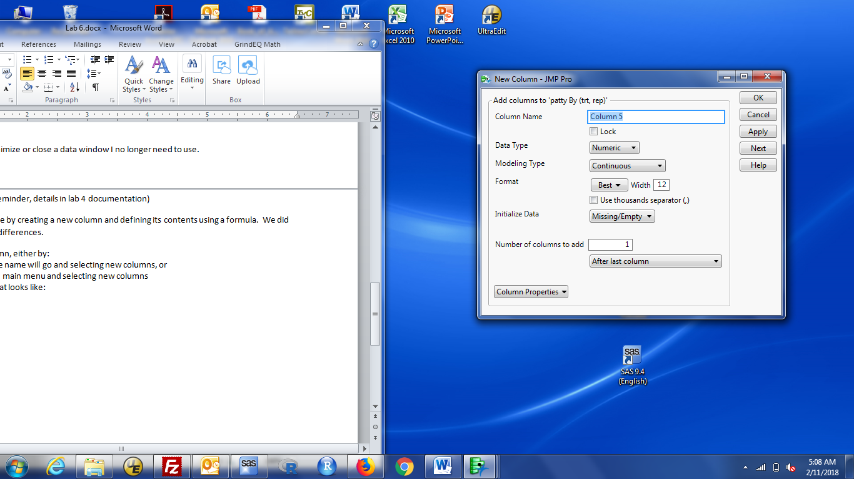

Type a more descriptive variable name, e.g., log mean CFU, in the Column Name box, then left click Column Properties (bottom left of dialog box) and choose Formula. You now use the buttons and menu choices to write the formula you want JMP to compute.

Click the variable name to use. Here, that's Mean(cfu), then find the log() function. It's under Transcendental, then either Ln or Log. Log is base e (natural log) by default. When ready, the formula dialog should look like:

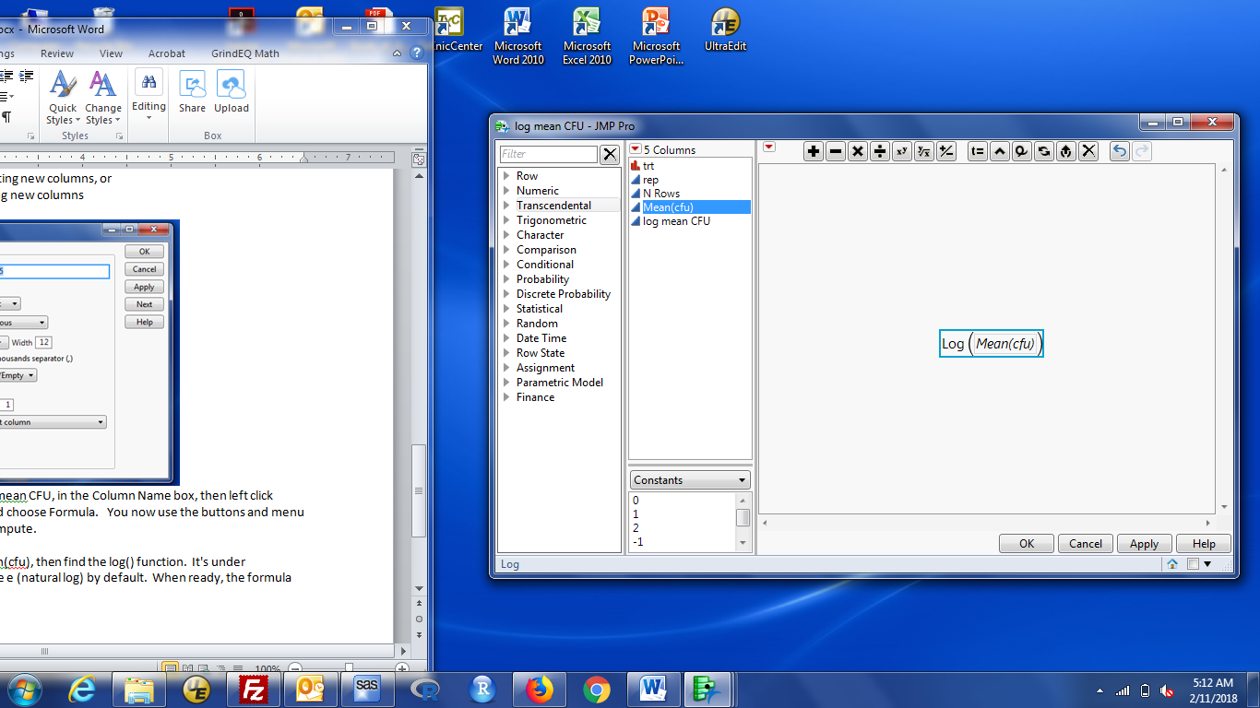

Click OK and the column in the data window is updated with the new name and contents.